DIGITAL MEDIA 1
Learning Element Tutorials
Graphic Design-Assignment 2

Name

- Open Adobe Photoshop

- Create four identical buttons (starting with a white canvas); however, make them as a:

  - One stage button (final graphic: 150 pixels wide by 50 pixels high)
  - Two stage button (final graphic: 150 pixels wide by 100 pixels high)
  - Three stage button (final graphic: 150 pixels wide by 150 pixels high)
  - Four stage button (final graphic: 150 pixels wide by 200 pixels high)

- The entire background color should be a blue-to-white gradient (any direction).

- Copy the Background layer, then use the fx button and choose Bevel and Emboss… (default settings)

- The button text attributes should include:

  - The text fill color should be white (stage one), black (stage two), yellow (stage three), and red (stage four)
  - The text should be: HELP (note: all caps)

    - Font size should be 30 pt
    - Font name should be Comic Sans MS
    - The text should be centered vertically and horizontally on the button (use the Flatten Image option when copying and pasting)

- When you have finished, have all buttons (four graphic files) on screen at once for your teacher to grade (just like you see below)

BUTTON TYPE (Number of Stages)

One Stage Two Stage Three Stage Four Stage
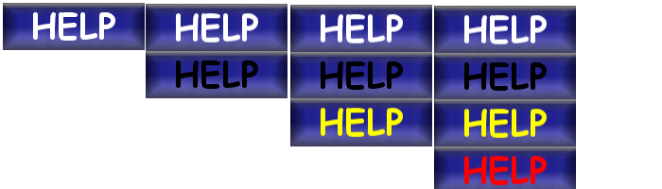
Move Off
(White)
Move On
(Black)
Click
(Yellow)
Release
(Red)

